**Pottery**

**Question a**

In the field of statistics, computer science, mathematics etc, distance matrix is defined as a square matrix containing the distances of pairwise observations in the data. There exist different methods for calculating distance matrix such as Manhattan, Cosine similarity and Euclidean. The choice of the method to use mainly relies on the data being analyzed, research context and the objective to be achieved.

**Figure 1.0**

*Dendrogram*

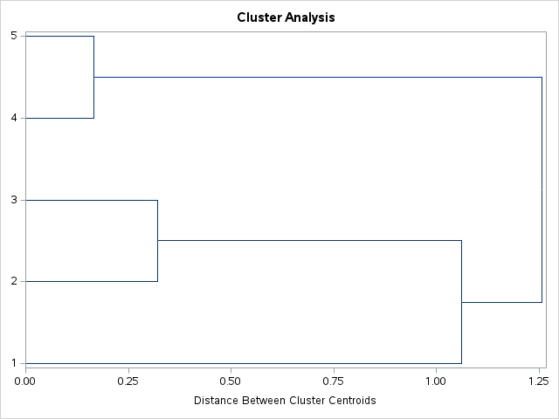

Determining the optimal number of clusters to use, requires a comprehensive analysis of the dendrogram produced. Upon analysis, the optimal number of clusters I would use is 2. This is supported by the fact that the most significant jumps occur between a distance of around 1.0 and 1.3 on the dissimilarity scale. Cutting the dendrogram just before this jump (around a distance of 1.0), it would result in a clear separation of clusters. Additionally, the largest gap in the dendrogram occurs just before a distance of 1.25, indicating a natural division into 2 clusters and this choice balances the need for simplicity with the desire to capture significant dissimilarities in the data. With 2 clusters, the most distinct separation in the data is captured.

**Question b**

Multidimensional Scaling (MDS) visualization results below determines the distinctiveness of Romano-British pottery samples based on their chemical analysis. The 45 pots of pottery samples were made in three different regions: Region 1 (Kiln 1), Region 2 (Kilns 2 and 3), and Region 3 (Kilns 4 and 5)

**Figure 2.0**

*MDS plot*

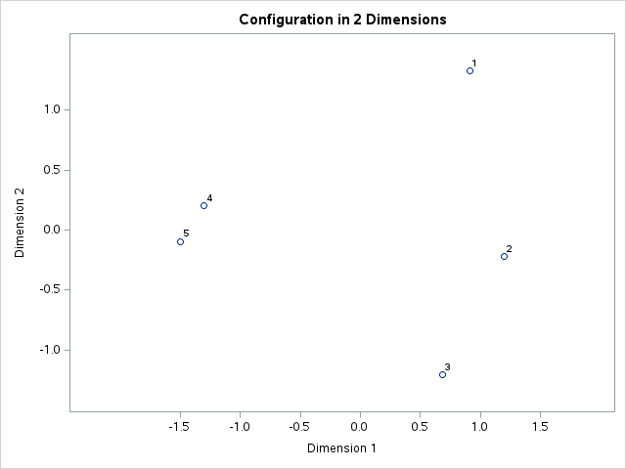

**Figure 3.0**

*MDS fit plot*

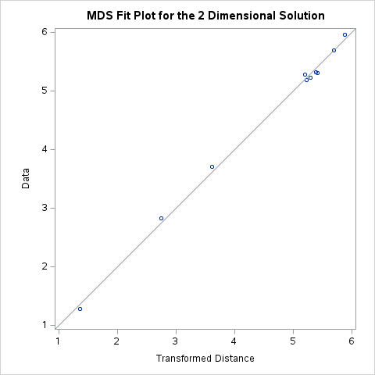

Points labelled 1 are grouped in the top right area of the plot. The tight clustering of these points suggests that the pottery samples from Kiln 1 share a distinct chemical composition, differentiating them from samples in other regions. Region 1 therefore appears to be chemically distinct from regions 2 and 3.

Points 2 and 3 are situated in the lower right and bottom center of the plot. Overlapping is identified between kiln 2 and 3 implying that their chemical properties are similar. Despite this internal similarity, the points are separate from those of Kiln 1, indicating that Region 2 is distinct from Region 1. However, the similarity between Kilns 2 and 3 within Region 2 suggests they are not distinct from each other but are collectively distinct from other regions.

Points 4 and 5 are clustered towards the left side of the plot. This clustering indicates that the pottery samples from Kilns 4 and 5 share a similar chemical composition. The clear separation from points labeled 1, 2, and 3 indicates that Region 3’s pottery samples are chemically distinct from those in both Region 1 and Region 2. Kilns 4 and 5 are not distinct from each other within Region 3 but collectively form a distinct group.

In summary, the Multidimensional Scaling results (MDS) indicate that Region 1 is distinctive, Region 2 is somewhat distinctive internally but separate from region 1, and region 3 is distinct from both Regions 1 and 2.

**References**

Recchia, A. (2010). Contiguity-Constrained Hierarchical Agglomerative Clustering UsingSAS. *Journal of Statistical Software*, *33*(Code Snippet 2). <https://doi.org/10.18637/jss.v033.c02>

Slavíček, K., Těsnohlídková, K., Košťál, M., Václavíková, D., & Trnová, K. (2024). Pottery kiln from the second half of the 13th century in Žďár nad Sázavou – Staré Město (Czech Republic). *Archeologické Rozhledy*, *75*(4), 403–438. <https://doi.org/10.35686/ar.2023.28>

Zhang, Y., & Ding, C. (2022). Using MDS preference plot as visual analytics of data: A machine learning approach. *Methodological Innovations*, *16*(1), 67–77. <https://doi.org/10.1177/20597991221144574>